Date:17/10/2022

COAL LAB Mid:

Name: Owais Ali Khan

Roll: 21K-3298

Section: 3-F

# Question # 01:

TITLE Question 1

INCLUDE Irvine32.inc

.data

var1 SWORD -10d, 20o, -30, 40o, -50, 60h, 80, -90, 100b, 110h, 120o, 130h, 140h, 150o, 160d

var2 SDWORD -80, -456, 98h, -4998, -9817, 9827, 68h, 628h, -7, 8943, 6798h, 1635, 87Ah

var3 SBYTE -85, -64, 47o, -46, 0Ah, 50d, 55, 19h, 20d, 10o

message BYTE "Value of ebx in decimal = ", 0

.code

main PROC

mov ebx, 0

add ebx, var2[1 * TYPE var2]

sub bx, var1[2 * TYPE var1]

sub bx, var1[3 * TYPE var1]

add bl, var3[4 * TYPE var3]

add bx, var1[5 * TYPE var1]

sub bl, var3[6 * TYPE var3]

add ebx, var2[7 * TYPE var2]

call Dumpregs

mov edx, OFFSET message

call WriteString

mov eax, ebx

call WriteInt

call Crlf

mov ebx, 0

add bx, var1[2 * TYPE var1]

add bx, var1[4 * TYPE var1]

sub ebx, var2[6 * TYPE var2]

add bl, var3[6 * TYPE var3]

sub bl, var3[8 * TYPE var3]

add ebx, var2[10 * TYPE var2]

add bx, var1[12 * TYPE var1]

call Dumpregs

mov edx, OFFSET message

call WriteString

mov eax, ebx

call WriteInt

call Crlf

exit

main ENDP

END main

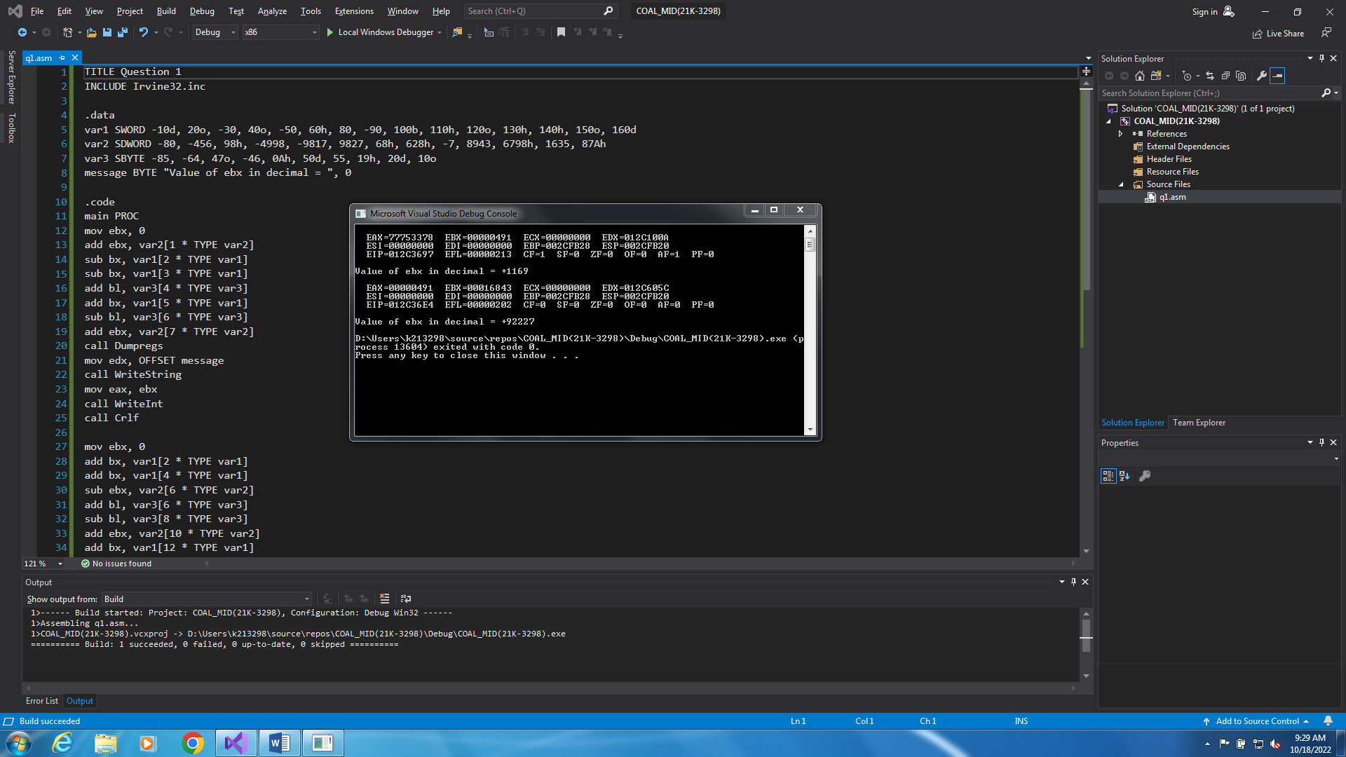

# Question # 02:

TITLE Question 2

INCLUDE Irvine32.inc

.data

count = 100

array SBYTE count DUP(?)

random SWORD ?

.code

main PROC

call Randomize

call Random32

mov random, ax

mov esi, 0

mov ecx, count

L1:

movzx eax, random

call RandomRange

mov array[esi], al

add esi, TYPE array

loop L1

mov esi, 0

mov ecx, count

PRINT:

movzx eax, array[esi]

call WriteInt

mov eax, " "

call WriteChar

add esi, TYPE array

loop PRINT

call Crlf

exit

main ENDP

END main

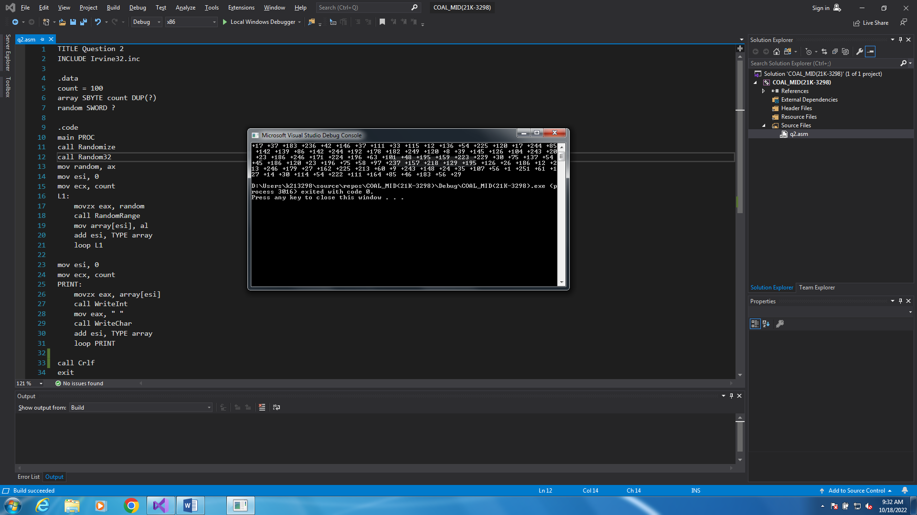

# Question # 03:

TITLE Question 3

INCLUDE Irvine32.inc

.data

count = 5

row DWORD ?

column DWORD ?

character DWORD "*"

space DWORD " "

prompt1 BYTE "Enter number of rows: ", 0

prompt2 BYTE "Enter number of columns: ", 0

prompt3 BYTE "Enter character", 0

.code

main PROC

mov edx, OFFSET prompt1

call Writestring

call ReadDec

mov row, eax

mov edx, OFFSET prompt2

call WriteString

call ReadDec

mov column, eax

mov edx, OFFSET prompt3

call WriteString

call ReadChar

mov character, eax

call Crlf

mov esi, 1

mov ecx, row

L1:

push ecx

mov ecx, column

L2:

mov eax, space

call WriteChar

loop L2

pop ecx

push ecx

mov ecx, esi

L3:

mov eax, character

call WriteChar

loop L3

call Crlf

pop ecx

inc esi

dec column

loop L1

exit

main ENDP

END main

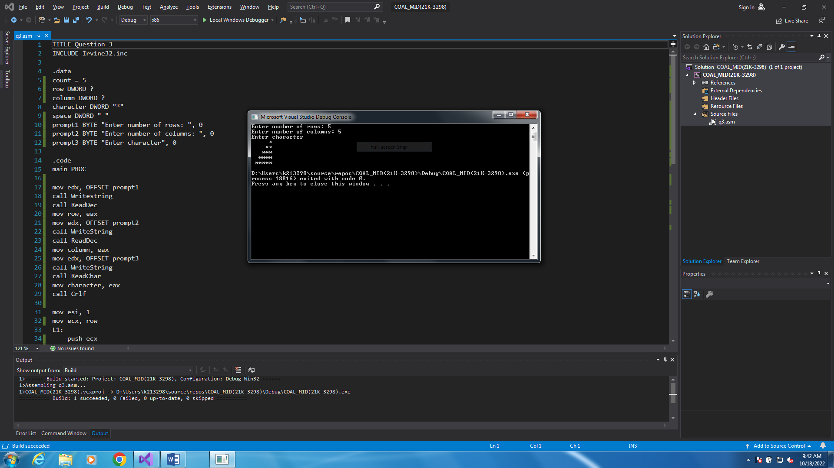

# Question # 04:

TITLE Question 4

INCLUDE Irvine32.inc

.data

startValue = 857

endValue = 434

.code

main PROC

call Randomize

mov al, 09Fh

mov ah, 00h

call SetTextColor

mov eax, startValue

mov ebx, endValue

call randomNumbers

exit

main ENDP

randomNumbers PROC

mov dl, 0

mov dh, 0

call WriteDec

add dh, 1

add dl, 2

mov ecx, 18

L1:

push eax

call GotoXY

add dh, 1

add dl, 2

call RandomRange

call WriteDec

pop eax

loop L1

call GotoXY

mov eax, ebx

call WriteDec

ret

randomNumbers ENDP

END main

